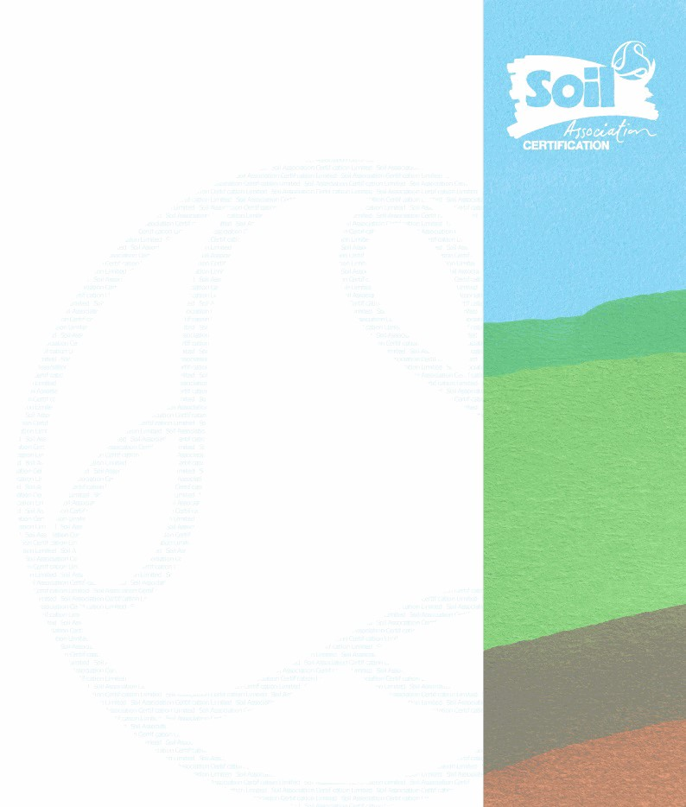
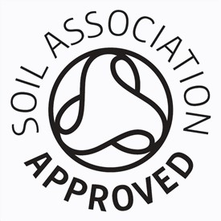

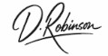
SAAL28123250626AI_Farms-0039-CD26
CERTIFICATE OF REGISTRATION
Fertiliser Ltd
Licence number: AL28123
Chestnut House
Main Road
Tallington
Linconshire
E9 4RP
GREAT BRITAIN
This is to certify that the above named has been inspected and satisfies the requirements of the Soil
Association standards for non-organic raw materials for use in organic farming. This certificate is
only valid for marketing certified products when accompanied by a current trading schedule. To
verify the current validity of this document, contact Soil Association Certification directly, or visit the
online directory at www.soilassociation.org/certification/find-a-licensee
Valid until the date stated, unless surrendered, suspended or revoked. This certificate remains the
property of Soil Association Certification and must be returned on request.
Issue date:
25.06.2026
Expiry date:
30.06.2027
Dominic Robinson
CEO
Ref: SA28123SPAI_Farms-0050-TS26250626
Soil Association Certification
Trading Schedule
Company Name: Fertiliser Ltd
Address: Chestnut House
Main Road
Tallington
Linconshire
E9 4RP
GB
Licence No: AL28123
The business above satisfies the requirements of the Soil Association Standards for Approved Inputs. Products listed are certified as inputs approved for use in organic production compliant with Regulations Retained in Great Britain 834/2007 and 889/2008, and EU regulation 2018/848.
This document lists the enterprises and products that have been licensed by Soil Association Certification Limited and is valid until the date stated, unless surrendered by the business or suspended or revoked by Soil Association Certification Limited.
Valid until 30/06/2027
This document may be used to market the following licensed products only:
Enterprises | Status
Processing/manufacturing | Approved
Product Name | Status
Orgamino - N13 | Approved
Orgamino N-7 Liquid | Approved
Issue date: 25/06/2026
Last annual inspection: 26/11/2025 Signed by:
Dominic Robinson, CEO
Soil Association Certification Limited, Spear House, 51 Victoria Street, Bristol BS1 6AD
T +44 (0) 117 914 2412 F +44 (0) 117 314 5046 cert@soilassociation.org

